SF.SmokeTestScripts_TC_SF_ManagerHomePageLinks_Instance1_18-Apr-2017_12-56-17_AM_Invoke_Application.png



SF.SmokeTestScripts_TC_SF_ManagerHomePageLinks_Instance1_18-Apr-2017_12-56-57_AM_Login.png

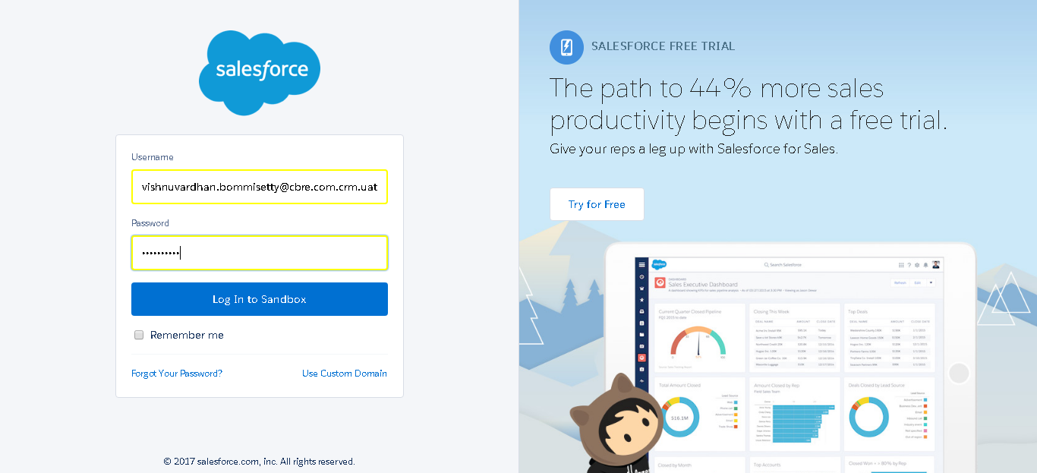

SF.SmokeTestScripts_TC_SF_ManagerHomePageLinks_Instance1_18-Apr-2017_12-57-34_AM_Verify_Login.png

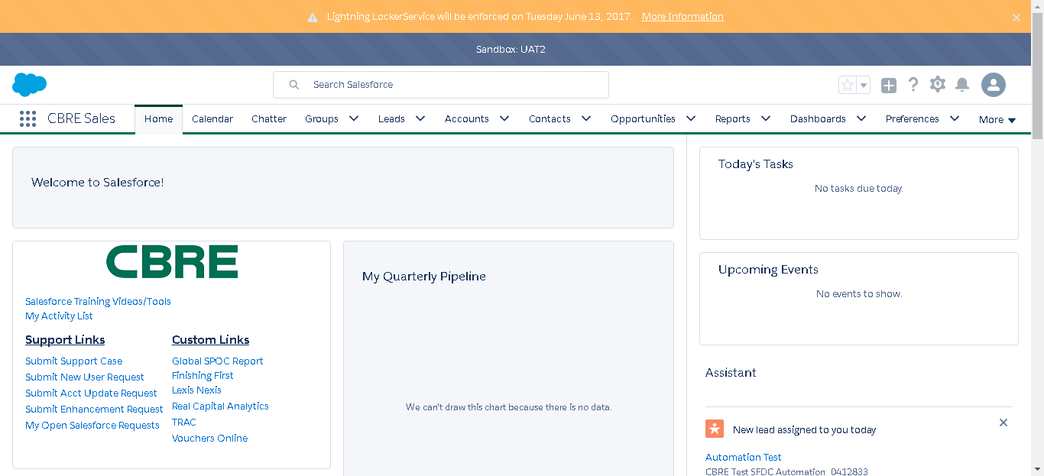

SF.SmokeTestScripts_TC_SF_ManagerHomePageLinks_Instance1_18-Apr-2017_12-57-35_AM_Verify_Home_Page_Links.png



SF.SmokeTestScripts_TC_SF_ManagerHomePageLinks_Instance1_18-Apr-2017_12-57-40_AM_Verify_Home_Page_Links.png



SF.SmokeTestScripts_TC_SF_ManagerHomePageLinks_Instance1_18-Apr-2017_12-57-46_AM_Verify_Home_Page_Links.png



SF.SmokeTestScripts_TC_SF_ManagerHomePageLinks_Instance1_18-Apr-2017_12-57-47_AM_Verify_Home_Page_Links.png



SF.SmokeTestScripts_TC_SF_ManagerHomePageLinks_Instance1_18-Apr-2017_12-57-50_AM_Verify_Home_Page_Links.png



SF.SmokeTestScripts_TC_SF_ManagerHomePageLinks_Instance1_18-Apr-2017_12-57-51_AM_Verify_Home_Page_Links.png



SF.SmokeTestScripts_TC_SF_ManagerHomePageLinks_Instance1_18-Apr-2017_12-57-52_AM_Verify_Home_Page_Links.png



SF.SmokeTestScripts_TC_SF_ManagerHomePageLinks_Instance1_18-Apr-2017_12-57-53_AM_Verify_Home_Page_Links.png



SF.SmokeTestScripts_TC_SF_ManagerHomePageLinks_Instance1_18-Apr-2017_12-57-54_AM_Verify_Home_Page_Links.png



SF.SmokeTestScripts_TC_SF_ManagerHomePageLinks_Instance1_18-Apr-2017_12-57-55_AM_Verify_Home_Page_Links.png



SF.SmokeTestScripts_TC_SF_ManagerHomePageLinks_Instance1_18-Apr-2017_12-57-57_AM_Verify_Home_Page_Links.png



SF.SmokeTestScripts_TC_SF_ManagerHomePageLinks_Instance1_18-Apr-2017_12-57-58_AM_Verify_Home_Page_Links.png



SF.SmokeTestScripts_TC_SF_ManagerHomePageLinks_Instance1_18-Apr-2017_12-58-00_AM_Verify_Home_Page_Welcome_Links.png



SF.SmokeTestScripts_TC_SF_ManagerHomePageLinks_Instance1_18-Apr-2017_12-58-06_AM_Verify_Menu_-_Accounts.png



SF.SmokeTestScripts_TC_SF_ManagerHomePageLinks_Instance1_18-Apr-2017_12-58-14_AM_Verify_Accounts_Home_Page.png

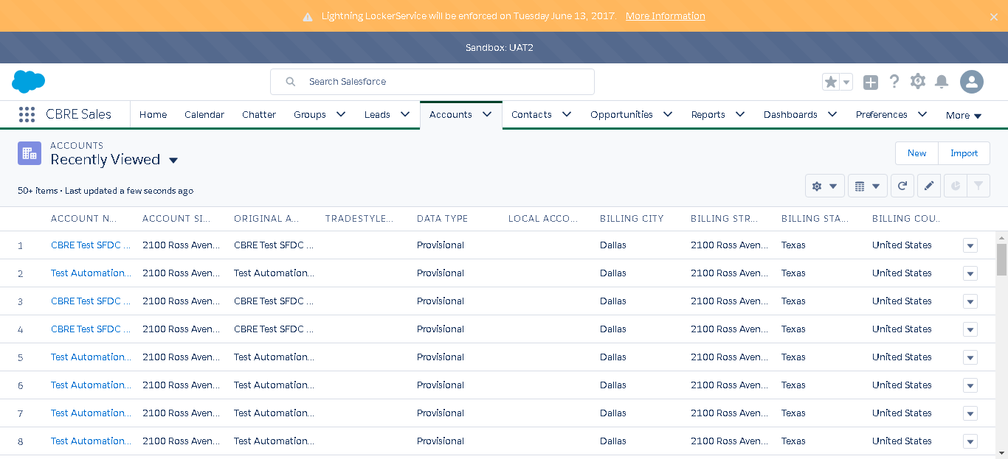

SF.SmokeTestScripts_TC_SF_ManagerHomePageLinks_Instance1_18-Apr-2017_12-58-19_AM_Verify_Menu_-_Opportunities.png



SF.SmokeTestScripts_TC_SF_ManagerHomePageLinks_Instance1_18-Apr-2017_12-58-26_AM_Verify_Opportunities_Home_Page.png

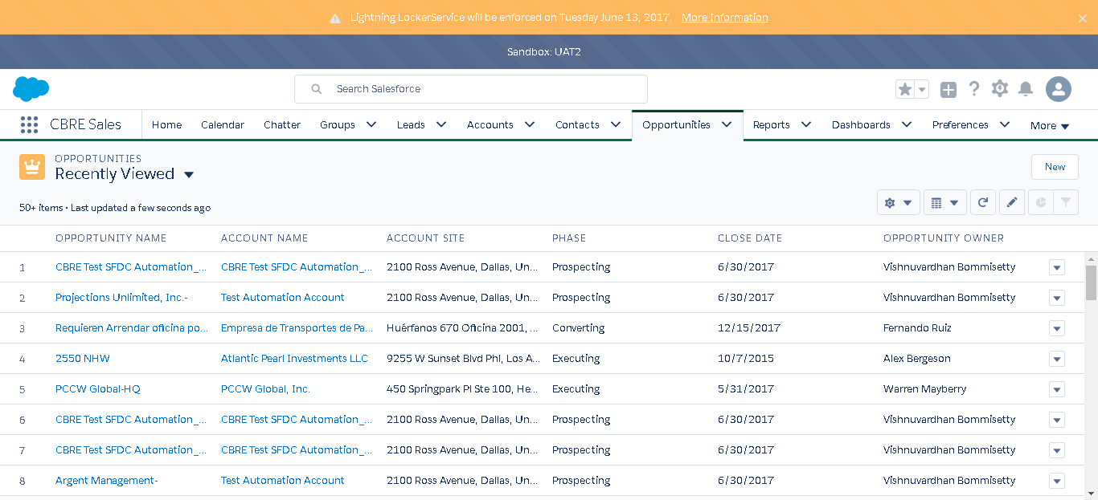

SF.SmokeTestScripts_TC_SF_ManagerHomePageLinks_Instance1_18-Apr-2017_12-58-31_AM_Verify_Menu_-_Leads.png

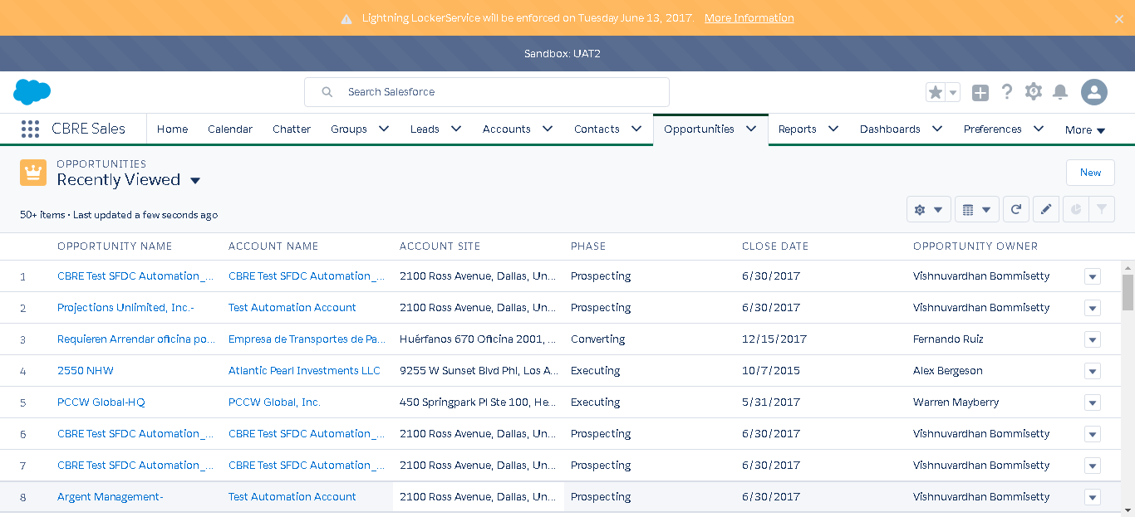

SF.SmokeTestScripts_TC_SF_ManagerHomePageLinks_Instance1_18-Apr-2017_12-58-41_AM_Verify_Leads_Home_Page.png

